Mthandazo L Moyo
Case study 5 – Pacific Trails Resort

Figure 2.40
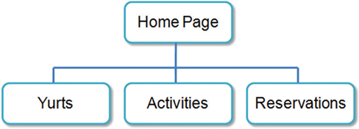

- Examine the site map in Figure 2.40. What type of site organization is used for the Pacific Trails Resort website? Is it the most appropriate organization for the site? Why or why not?
- This treelike structure where the parent, our homepage links down to child pages like yurts, activities and reservations is called Hierarchical organization
- I think for what the Pacific Trails Resort page is trying to do, this organizational structure is appropriate.
  - Why this works: Pacific trails is a resort and needs people to book. Thus, by having this website in Hierarchical form allows people to just head over to sections they need without having to browse through sections things. Instead of having to skim through pages like activities or yurts just to get a reservation

- web design practices: Review the recommended web design practices from this chapter. Use the Web Design Best Practices Checklist (Table 5.1) to evaluate the Pacific Trails Resort site that you created in earlier chapters. Cite three design practices that have been well implemented. Cite three design practices that could be implemented in a better way. How else would you improve the website?
  - Three design practices well implemented
    - Hierarchy: As I said before, hierarchy is a good move in designing this website. Users get to where they want to go with fewer clicks
    - Content Grouping: The content is grouped nicely, for example yurts is separate from activities making it easier to find information and predict where certain things will be
    - Very simple: The site is simple and not cluttered. There are only 3-4 things in the cite right now
Three Design Practices to Improve:
- There is no contact information. There should always be contact information even in the beginning stages of a webpage. Just in case a customer needs it
- This wouldn’t matter for some pages but a resort page there must be a about us part. This website does not look legit and without a about us it necessarily does not build trust.
- This is fixed in the later chapters but for now the website does not have visual variety. Site feels empty, I think a lot more pictures would be a big help

